**The Sanitation Challenge: A Stakeholder's Guide (SaniBook)**

**Introduction: Why Sanitation Matters**

Sanitation is a critical foundation for public health, environmental sustainability, and economic development. However, significant challenges obstruct the path to achieving universal access to safely managed sanitation. This Sanibook outlines the key barriers we must address to drive sustainable progress.

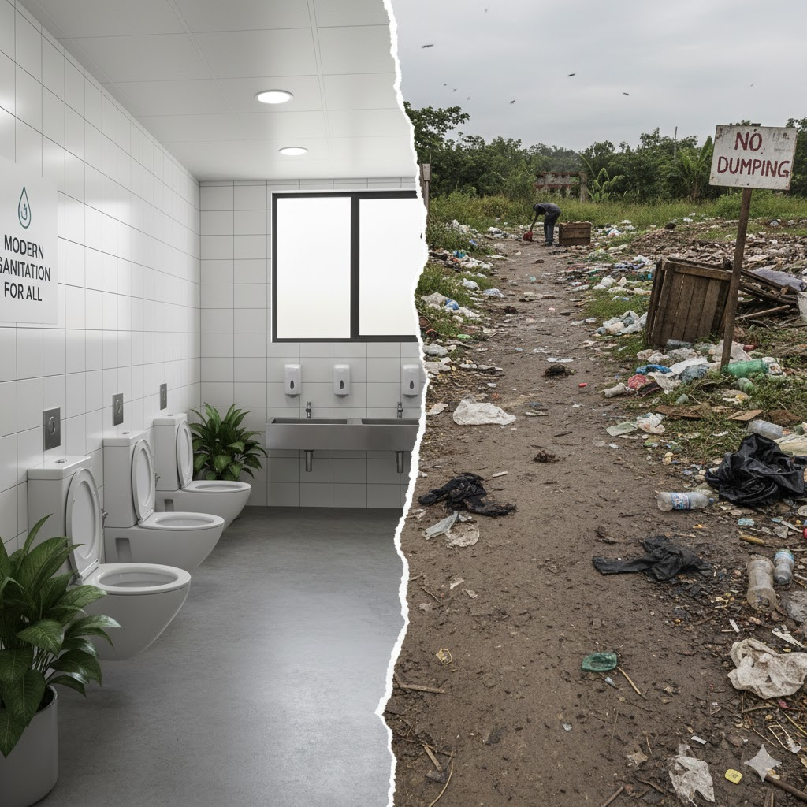

Contrast between a healthy, modern sanitation facility and a scene of open defecation or an unmanaged waste area

**1.1: The Unseen Current: How Poor Sanitation Undermines Even the Safest Neighborhoods**

Sanitation often feels like a localized issue. We build our clean facilities, manage our waste responsibly, and assume our immediate environment is secure. However, this assumption overlooks a critical truth*: In a connected world, poor sanitation in one area inevitably impacts others, even those with seemingly robust systems.* No neighborhood is an island when it comes to public health.

**1.2: The Illusion of Isolation**

Imagine a community divided. On one side, neat rows of houses boast modern plumbing, advanced wastewater treatment, and regular waste collection. Children play in clean parks, and residents enjoy pristine water. On the other side, just a few blocks away, the scene is starkly different: open defecation is common, waste piles up in alleys, and contaminated water flows freely.

Many might believe that the well-sanitized area is immune. "Our systems protect us," they might think. But the invisible forces of disease and environmental degradation are not constrained by property lines or municipal boundaries.

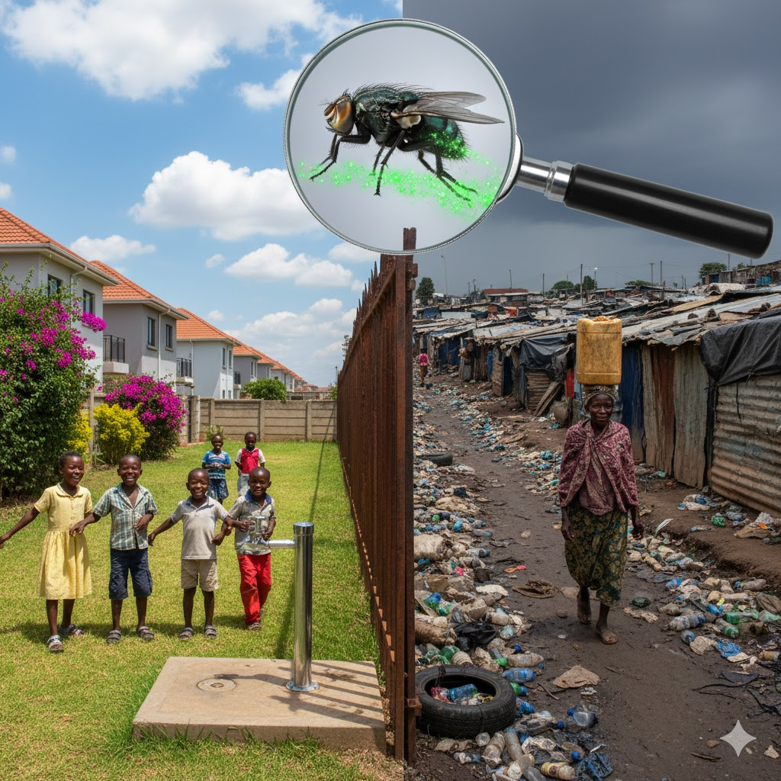

*Sanitation Divide: Where Poverty and Privilege Share Pathogens.*

This visual serves as a powerful critique of global health inequality, using the magnified image of a disease-carrying fly crossing a segregating fence to illustrate that sanitation crises in marginalized communities inevitably threaten adjacent, privileged populations.

**1.3: The Invisible Bridge of Contamination**

1. **Vectors Don't Discriminate:** Disease vectors like flies and mosquitoes thrive in areas with poor sanitation and easily cross boundaries. A fly exposed to waste in a slum can quickly carry pathogens (like cholera or typhoid) to a nearby clean neighborhood, landing on food or children, demonstrating that health crises in one area pose a direct threat to all adjacent communities.
2. **Water Knows No Boundaries:** Contaminated runoff from poorly sanitized areas easily compromises shared groundwater and surface water, escalating the risk of waterborne disease outbreaks and increasing water treatment costs for even well-maintained neighboring communities.
3. **Airborne Pathogens and Odor:** The stench from unmanaged waste carries airborne pathogens and particles, contributing to widespread air quality degradation that negatively affects all nearby communities.
4. **Economic and Social Strain:** An outbreak of disease originating in a poorly sanitized area will inevitably put a strain on the entire region's healthcare system, affecting hospitals, clinics, and resources that serve both communities. Businesses may suffer, tourism can decline, and the overall social fabric can fray due to fear and illness. No community can truly prosper in isolation when its neighbors are struggling with fundamental public health crises.

**1.3.1: The Ripple Effect: Beyond Immediate Health**

The impact extends beyond immediate health risks:

* **Property Values:** Proximity to poorly managed waste areas can depress property values and deter investment, even in otherwise well-maintained areas.
* **Environmental Degradation:** The overall ecosystem suffers. Contamination of shared natural resources like rivers, lakes, and even coastal areas affects recreational activities, fishing, and biodiversity for everyone.2
* **Stigma and Inequality:** The stark divide perpetuates social inequalities and can lead to stigma, making it harder to address the root causes of poor sanitation across the board.

**1.4: A Shared Responsibility**

The fundamental lesson is clear: **sanitation is a collective responsibility.** The health and well-being of a neighborhood with safe, modern sanitation facilities are inextricably linked to the sanitation practices of its surrounding areas. Addressing poor sanitation in one part of a city or region isn't just an act of charity or social justice; it's an act of self-preservation for all.

Investing in universal access to safe sanitation, promoting hygiene, and ensuring proper waste management everywhere are not just moral imperatives—they are essential steps toward building truly resilient, healthy, and safe communities for everyone, no matter where they live.

Sanitation is not just about waste; it's about dignity, public health, and environmental stewardship.1 The difference between **modern, managed sanitation** and the grim reality of **unmanaged waste** is a stark visual and tangible contrast, defining the health and future of a community.

**Interventions**

**Chapter 2 The Seven Bottlenecks: Why Global Sanitation is stalling**

The global drive to achieve **SDG 6.2 (Safely Managed Sanitation)** is severely hampered by seven critical obstacles, precisely defined during the **Sanitation Accountability Symposium**. These "Seven Bottlenecks" reveal systemic failures in governance and finance that undermine both service delivery and long-term sustainability. Progress stalls due to **Chronic Underfunding and Low Prioritization** and **Inadequate and Untargeted Financing**, which disproportionately funds basic toilet construction while neglecting the costlier, yet crucial, full service chain. This is compounded by the **Failure to Prioritize the Entire Sanitation Chain**—a focus on access over safe waste containment and treatment—and a pervasive **Lack of Institutional and Political Leadership**, resulting in fragmented governance that struggles to coordinate complex, multi-sector efforts.

The remaining challenges address severe operational and external pressures. **Rapid Urbanization and Informal Settlements** create unmanageable service demands in high-density areas that existing infrastructure cannot serve, while **Weak Regulation and Accountability** allow unsafe practices, such as illegal waste dumping, to persist unchecked. Furthermore, the sector is limited by **Insufficient Capacity and Innovation Uptake**, suffering from a critical shortage of trained personnel needed to manage and scale modern, decentralized solutions. Finally, the growing threat of **Climate Change Impacts and Resilience** requires a shift in planning, as extreme weather events actively destroy facilities and jeopardize public health gains, demanding that all new investments be climate-smart and durable.

**2.1: Beyond the Drain: How Safely Managed Sanitation Can Catalyze Kenya's Development Agenda**

Kenya stands at a critical juncture where the crisis of inadequate **sanitation** directly collides with its aspirations for **sustainable development**. The country's rapid urban growth, particularly in bustling informal settlements, has strained existing infrastructure to a breaking point. The result is a stark sanitation deficit: a widespread reliance on unimproved or failing systems that funnel untreated human waste directly into the environment, tragically polluting vital water bodies like the Nairobi River.

This ongoing deficit is more than an environmental issue; it is a profound threat to human potential. It fuels cycles of debilitating **waterborne diseases** such as **cholera** and **typhoid**, which place an immense and unnecessary burden on public health resources and erode economic productivity. The cost of 'doing nothing' is simply too high.

The path to progress is clearly defined by **Sustainable Development Goal (SDG) 6.2**: achieving access to adequate and equitable sanitation and hygiene for all, with a focus on **Safely Managed Sanitation**. For Kenya, this paradigm shift is transformative and necessary.

| SDG | Deficit Implication (Barrier) | Sustainable Sanitation Implication (Accelerator) |
| --- | --- | --- |
| **SDG 1 (No Poverty)** | High health costs from illness and lost workdays keep families trapped in poverty. | Reduces healthcare expenses, increases productivity, and unlocks economic benefits (estimated return of $5.50 for every $1 invested). |
| **SDG 2 (Zero Hunger)** | Water contamination from untreated waste causes diarrheal diseases that lead to **malnutrition and stunting** in children. | Contributes to better nutrient absorption, reduces child stunting, and enables **safe water and nutrient recycling** for agriculture. |
| **SDG 3 (Good Health and Well-being)** | The primary cause of preventable deaths, particularly among children under five, from waterborne diseases. | Prevents millions of deaths and illnesses, reduces hospital strain, and contributes to overall public health resilience. |
| **SDG 4 (Quality Education)** | Students, especially girls, miss school due to illness or lack of private, safe, and clean toilet facilities. | Improves school attendance and educational outcomes, particularly for girls, by providing dignity and safety. |
| **SDG 5 (Gender Equality)** | Women and girls face disproportionate risk of assault and privacy issues when using shared or open defecation sites. | Ensures safety and dignity, saves time spent caring for the sick, and supports safe **Menstrual Hygiene Management (MHM)**. |
| **SDG 8 (Decent Work and Economic Growth)** | Lost productivity and days of work/school due to illness. | Promotes a healthier workforce, creates new "green jobs" in waste management and resource recovery, and boosts economic activity. |
| **SDG 13, 14, 15 (Climate Action, Life Below Water, Life on Land)** | Untreated waste pollutes oceans, freshwater, and land ecosystems; sanitation systems are vulnerable to climate disasters. | Protects ecosystems from pollution, can generate **renewable energy** (biogas), and promotes resilient, climate-smart infrastructure. |
| **SDG 16 (Peace, Justice, and Strong Institutions)** | Resource conflicts over contaminated water; weak local governance for service delivery. | Builds stronger, more responsive local institutions for service management and reduces potential conflict over scarce clean water. |

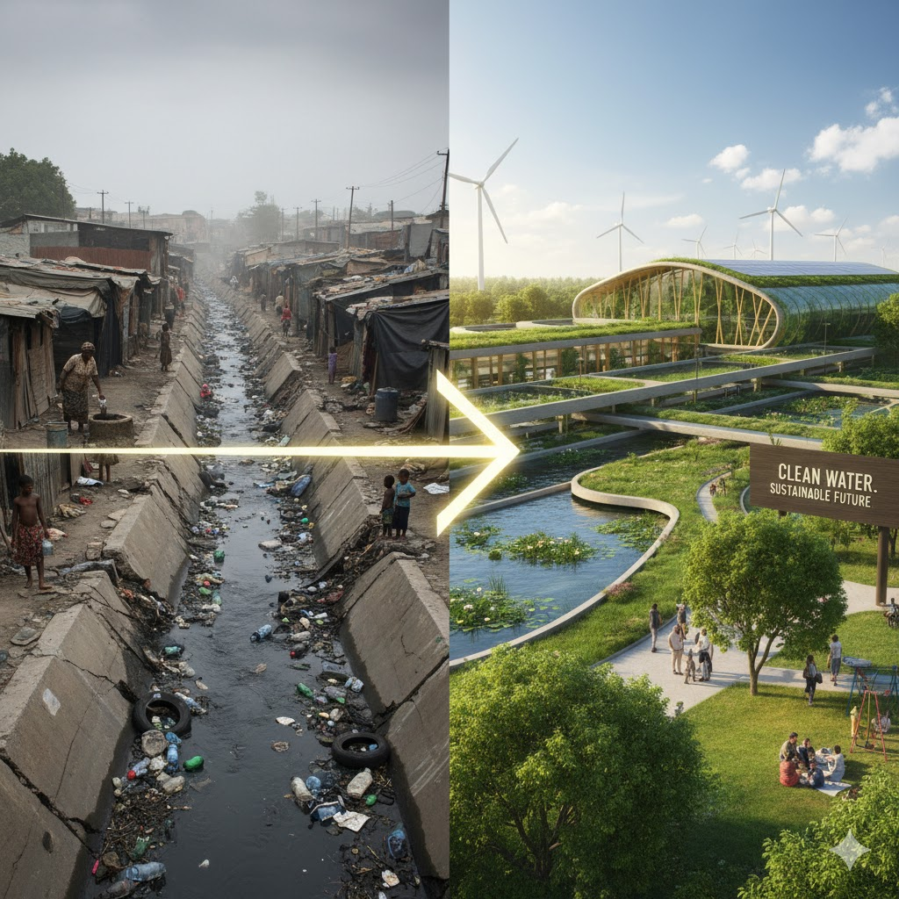

*Contrast between the current sanitation deficit and the desired future state: a clean, sustainable sanitation system*

**Who is intervening?**

**Chapter 3: Challenge 1: Widespread Access and Coverage Gaps 📉**

Significant portions of the population **still lack access to safely managed sanitation**6. The gaps are profound:

* Over **17% of the population still practices open defecation**7.
* More than half of residents in densely populated **informal settlements** rely on shared or unimproved toilet facilities, which highlights a deep equity gap8.

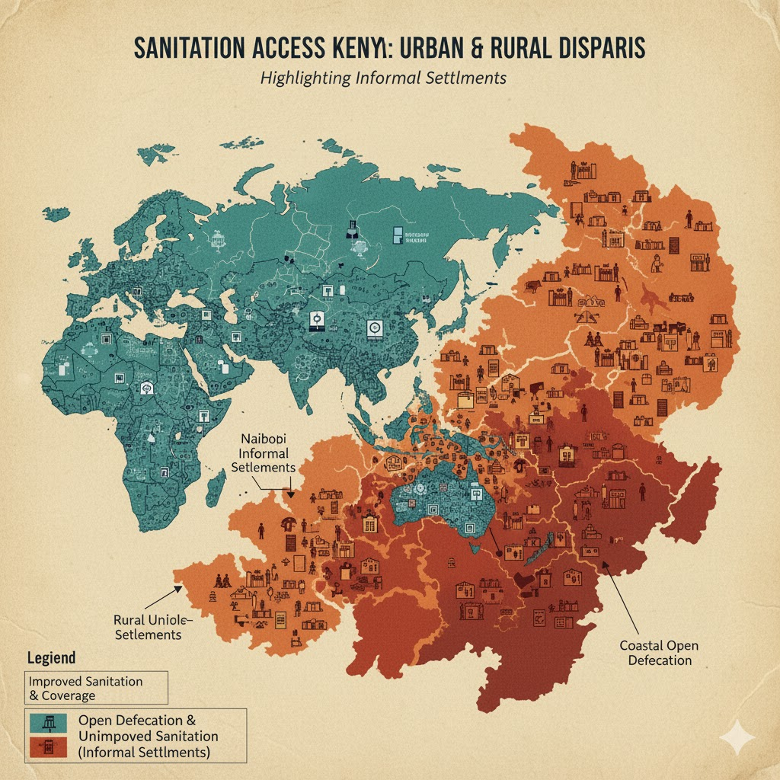

The Paradox: Contrasting Sanitation Access

**3.1: The Critical Gap: Open Defecation and Uneven Sanitation Access in Kenya**

Kenya has made commendable strides in its development agenda, yet achieving **universal and safely managed sanitation** remains one of the country's most pressing public health and equity challenges. While national figures show progress, the reality on the ground is marked by extreme disparities, with millions still excluded from basic dignity and safety.

The most visible failure in sanitation is the persistence of **Open Defecation (OD)**. Despite national campaigns and policy commitments, millions of Kenyans still lack access to a private, improved toilet and resort to defecating in fields, bushes, or water bodies.

Kenya has over **4.7 million people** still practicing **open defecation (OD)**, a direct assault on human health that significantly fuels infectious diseases that cost the Kenyan economy **US$88 million annually** due to poor health and lost productivity. This public health emergency is primarily a reflection of profound **geographic and economic inequality**. Over **85% of all OD** is concentrated in just 15 high-burden counties—largely in the Arid and Semi-Arid Lands (ASALs)—where **poverty is the dominant predictor** of sanitation failure, reinforcing the urgent need for strategic investment in sanitation as a fundamental economic imperative.

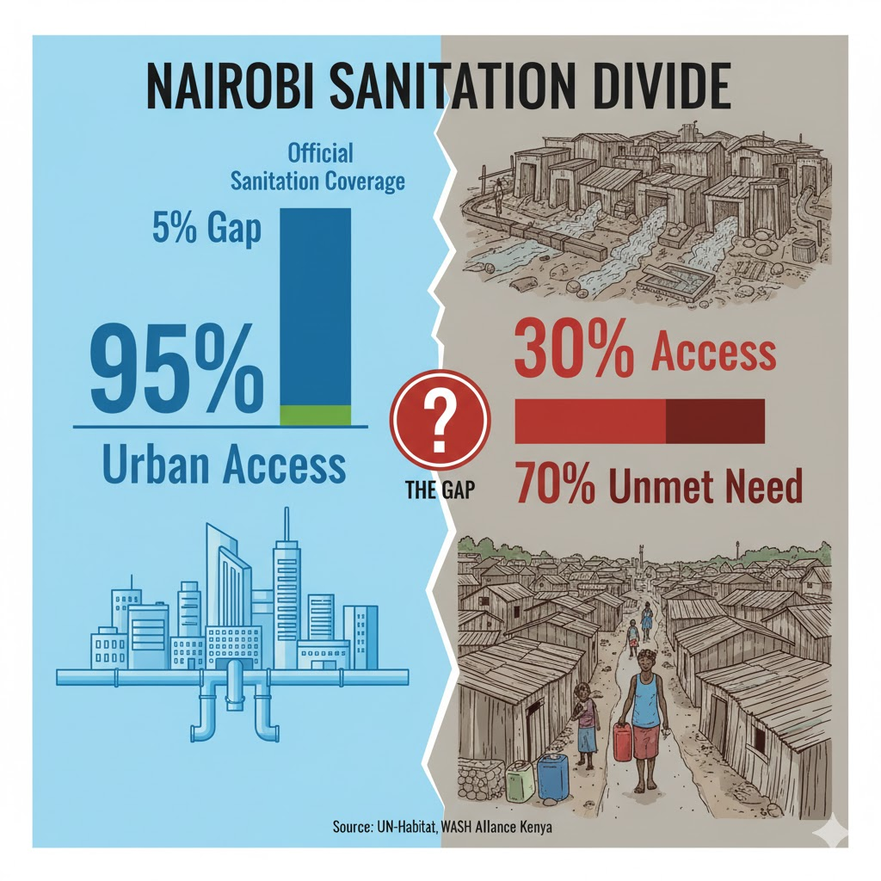C*overage gap: Contrasting official numbers with the reality in vulnerable areas like informal settlements.*

Kenya's official urban sanitation statistics, which often suggest high national coverage. This amount to **masking a severe public health crisis** in informal settlements. These aggregate figures are usually skewed by data from wealthy, formally planned neighborhoods which are connected to sewer lines. However, the vast majority of slum dwellers are critically underserved, with **less than 20%** of Nairobi's total inhabitants benefiting from the municipal sewer system. Furthermore, the statistical classification of a shared facility as "improved sanitation" is often misleading; in the extreme population density of slums, a single toilet may be forced to serve **80 or more households**. This extreme burden renders the facility functionally inadequate and unsanitary, transforming it into a severe health hazard that exposes a massive, hidden coverage gap and highlights that official progress is, for many, an illusion.

**The Stark Reality**

Kenya's severe **sanitation crisis** is fundamentally rooted in a **data failure**, as official metrics systematically obscure the unsafe realities for the over **70% of the population** residing in rural areas and urban informal settlements. This **systemic data exclusion** effectively omits these critical areas from utility mapping and infrastructure budgets, leading to a complete collapse of the sanitation value chain. Without accessible and safe services, residents are forced to rely on unsanitary infrastructure, unsafe manual waste removal, and direct dumping into waterways, which fuels persistent environmental degradation and frequent outbreaks of **waterborne diseases** like cholera and typhoid. This also imposes a devastating **Health and Dignity Cost**, including heightened security risks, especially for women and girls. To close this gap, the government must pivot from simply counting toilets to accurately measuring **safely managed sanitation**, which requires tracking the entire waste lifecycle—from containment to disposal or reuse—and committing to formal investment in context-specific, sustainable solutions like simplified sewer systems and decentralized treatment plants.

**Closing the Gap: From Counting to Safe Management**

Kenya needs to **shift its sanitation focus** from the **mere counting of toilet structures** to the **actual measurement of safely managed sanitation**, tracking the **full waste lifecycle** and **officially integrating informal settlements** into infrastructure budgets and planning to deliver the human right to sanitation.

**Chapter 3. The Perpetual Bottleneck: How Financial Scarcity Stifles Innovation and Service Expansion**

In the dynamic world of sanitation and specifically in Kenya, innovation and service expansion are the critical of engines of sanitation progress. Yet, they frequently grind to a halt before a familiar and formidable obstacle: *‘Financial scarcity’*. This perennial challenge, which affects organizations from grassroots NGOs to major municipal utilities, acts as a perpetual bottleneck, suffocating promising new technologies and restricting the vital outreach needed to serve unreached communities. Sufficient funding doesn't merely slow development—it fundamentally stifles the revolutionary potential inherent in the sanitation sector, turning essential aspirations into deferred dreams.

***3.1: Affordability and Low Household Prioritization of Sanitation***

For many people struggling with **poverty**, sanitation improvements are often overlooked in household budgets, as they compete with other vital family expenses. Compounding this, there is generally a low demand for on-site sanitation financing and products. This indicates a pressing need to significantly increase public awareness of the value and long-term benefits of improved sanitation.

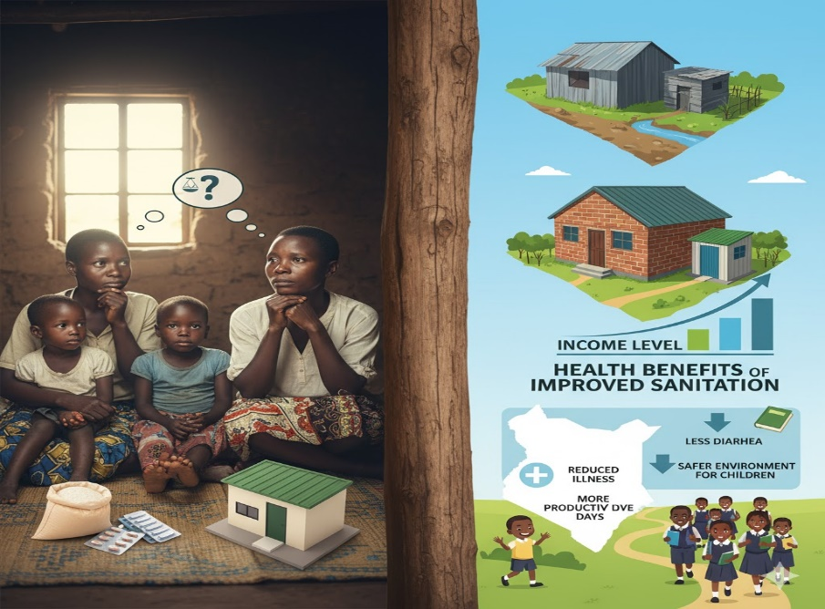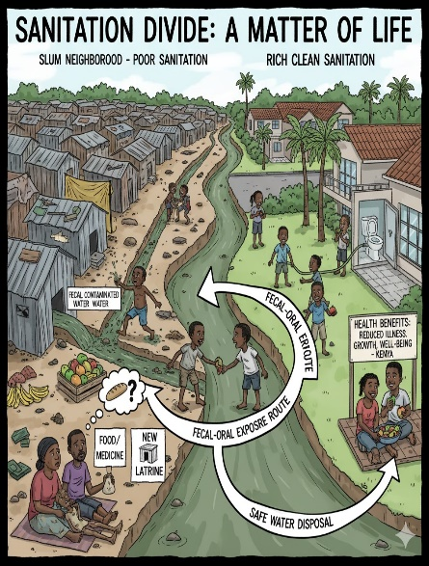

Family weighing choices between food/medicine and a new latrine; the other side showing the health benefits of improved sanitation.

**3.2: The Hard Choice: Balancing Immediate Needs Against the Dignity of a Toilet**

For countless families across Kenya, the decision to acquire or upgrade a toilet isn't a simple matter of convenience—it’s a **profound and often painful balancing act** between immediate, urgent needs and the long-term imperative of health and dignity. This choice is deeply tied to a family’s income group, creating a stark divide in sanitation access and resulting in significant health inequities. However, neglecting slum sanitation is a dangerous, shortsighted mistake because it creates a "weak link" that exposes the health, economy, and stability of the entire city, including its wealthy areas, making comprehensive sanitation for all a necessary public health investment, not an act of charity.

**3.3: The Squeeze: Why Sanitation Sinks on the Priority List**

In low-income communities, particularly in urban slums and rural areas, investing in a safe toilet is often a **luxury that families can't afford** due to the immediate, desperate pressure of daily survival. This results in agonizing, zero-sum choices:

**Survival vs. Sanitation:** Survival demands push sanitation down the priority list, as families choose **food over toilets** and **school fees over dignity**, often undermining a child's future.

1. **Food Wins:** Poor households often divert the **significant one-time investment** required for **sanitation** (like building a toilet or paying a connection fee) to meet the more immediate need of **food security**.
2. **Education vs. Dignity:** Parents prioritize school fees for a child's future. Ironically, the lack safe toilet can be a major barrier to education, causing missed days or even school dropout, especially for adolescent girls once they start menstruating.
3. **The Renters' Dilemma:** In areas with high tenancy, like Nairobi's slums, there is a misalignment of incentives between landlords and tenants.
4. **Tenants** are unwilling to invest in property they don't own
5. **Landlords** are often reluctant to pay for repairs or upgrades, focusing instead on rent collection. This deadlock leads to **poorly maintained, shared facilities** and a continued reliance on **open defecation**.
6. **The Hidden Costs**

Even when sanitation is neglected, its costs are paid elsewhere. Healthcare expenses for sanitation-related illnesses consume significant portions of meagre family incomes, perpetuating the cycle of poverty.

1. **The Middle-Class Barrier**

For working and middle-class families, the barrier shifts from absolute impossibility to perceived value. While they can afford a basic toilet, they often postpone investing in higher-quality, safer systems (like a sewer connection or a pour-flush toilet) because they don't fully appreciate the long-term health benefits compared to a functional, existing basic latrine.

**3.4: The Payoff: Health Benefits Across Income Groups**

**Improved Sanitation as an economic engine for Low-Income Households:** Improved sanitation is a vital economic cornerstone that disproportionately benefits low-income households by driving improvements in health and productivity. It rapidly cuts the disease burden (like cholera and typhoid) by interrupting the faecal-oral cycle, significantly lowering healthcare costs and conserving precious income to break the poverty cycle. Moreover, private household sanitation is a direct investment in human capital, delivering social gains: it reclaims valuable time for women and girls from risky trips for defecation, enabling them to pursue education and economic activities, while crucially enhancing their safety and dignity by protecting them from sexual violence associated with communal facilities.

**Benefits of Quality Sanitation for Middle- and High-Income Families:** For middle- and high-income families, the advantages of investing in quality sanitation pivot toward sustained public health, environmental quality, and economic stability. Their investment underpins large-scale environmental protection by ensuring the safe disposal and treatment of waste, which in turn reduces the contamination of local water sources for the entire community. Furthermore, high-quality sanitation is critical for optimal child development, minimizing exposure to pathogens that cause stunting and malnutrition and thereby securing children's full cognitive and physical potential 🧠. Economically, particularly in urban areas, a plumbed, quality sanitation facility serves as a vital amenity that directly increases property value and rental income.

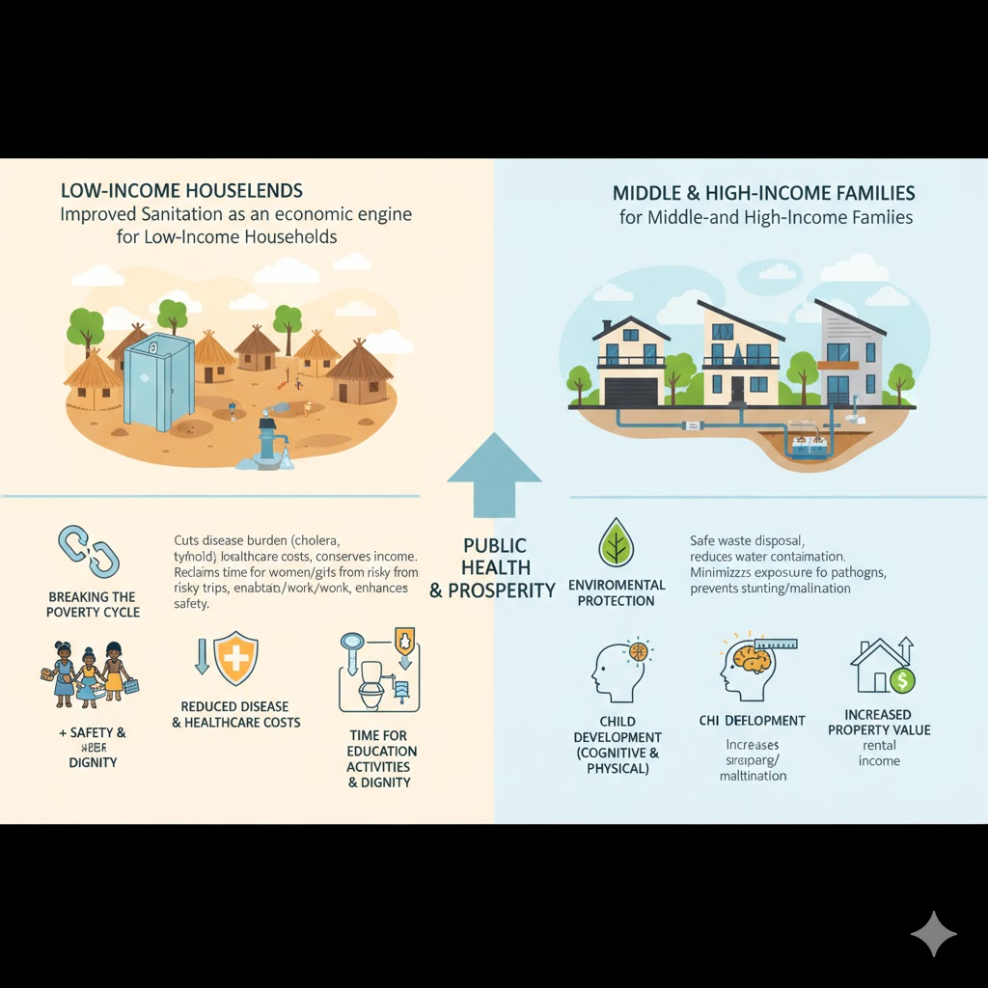 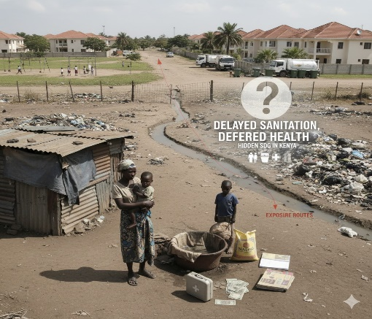

The Payoff: Health Benefits across Income Groups. Delayed Sanitation, Deferred Health, and hidden SDG Costs: No one is safe

**Chapter 4: Inappropriate Technologies and Sustainability Failures**

Kenya, a nation of diverse landscapes and dynamic development aspirations, presents a compelling case study in the challenges of achieving sustainable sanitation; a critical component of public health, dignity and environmental integrity. Despite significant investment and numerous intervention efforts, sanitation projects across the country are frequently undermined by the deployment of inappropriate technologies. These failures often stem from a critical mismatch between imported or standardized solutions and the highly variable local conditions. This includes and not limited to socioeconomic and behavioral variables, Environmental and Geographic Variables, and Institutional and Governance Variables. Compounding this technological hurdle is the pervasive issue of sustainability failures, primarily manifesting as chronically inadequate operations and maintenance (O&M) for installed systems, rendering infrastructure unusable shortly after handover. Moreover, a persistent lack of inclusivity ensures that the benefits of new sanitation solutions remain inaccessible to vulnerable groups—including the elderly, people with disabilities, and low-income populations—perpetuating cycles of inequity and incomplete coverage. This chapter will explore how these systemic issues in technology choice, O&M, and social inclusion converge to stymie Kenya's progress toward comprehensive and enduring sanitation for all.

**4.1: Undermining Progress: How Inappropriate Technology, Poor Maintenance, and Exclusion Stifle Sustainable Sanitation in Kenya**

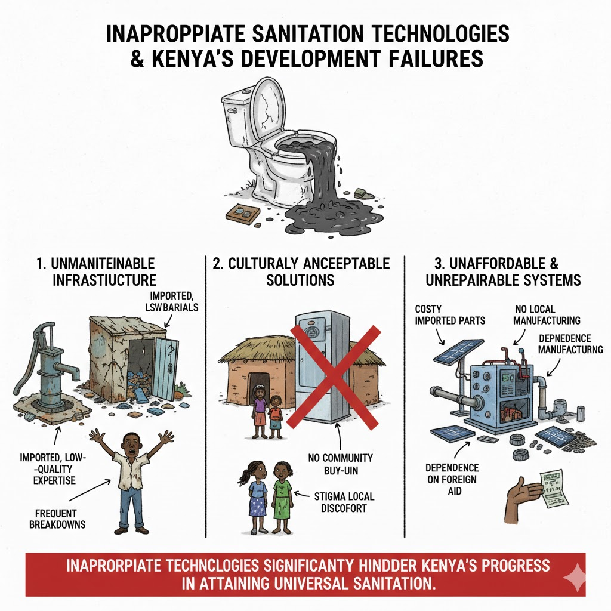

**4.1.1: Beyond the build: Overcoming Kenya's Tech Mismatch, Maintenance Malaise, and Exclusion Crisis to Deliver Universal Sanitation**

Kenya's drive toward universal, safe, and sustainable sanitation faces a trio of interconnected challenges: the deployment of **inappropriate technologies**, chronic **operations and maintenance (O&M) failures**, and a persistent **lack of inclusivity**. These issues often undermine well-intentioned projects, leading to premature failure and a continuous cycle of inadequate sanitation coverage, especially for the most vulnerable.

**4.1.2: The Mismatch in Kenyan Sanitation**

Kenya's drive for sustainable sanitation is undermined by a critical "mismatch": the failure to tailor standardized technology to the unique local environment. This reliance on a one-size-fits-all approach inevitably leads to system breakdown and abandonment across the country.

The core problem stems from ignoring crucial geographic and environmental variables. Key factors where the mismatch occurs:

* **Soil and Geology:** Hard, rocky ground makes traditional pit excavation (for latrines or septic tanks) impossible or prohibitively expensive. Conversely, sandy soils and high water tables create a serious risk of groundwater contamination, rendering conventional pit systems unsafe.
* **Climate and Hydrology:** Seasonal heavy flooding and monsoons destroy or fill open pits. In water-scarce regions, water-intensive flush systems are immediately non-viable and quickly abandoned.
* **Topography:** Steep slopes complicate gravity-fed sewer lines, often requiring costly pumping stations, which are difficult to maintain.

The clear lesson is that **Context is King**. For sanitation systems to achieve longevity in Kenya, a fundamental shift is required:

1. **Innovation and Adaptation:** Hardware must be locally adapted—
2. **Robust, Diverse Supply Chains:** with specialized, context-specific hardware supported by local supply chains and expertise to prevent system collapse due to a single failure point.

By prioritizing local context over standardized solutions, Kenya can move from a cycle of costly system failure to one of resilient, enduring progress in the sanitation sector.

## **4.1.3: The Sustainability Crisis: Inadequate O&M**

The sustainability of Kenya's sanitation infrastructure is severely compromised by the persistent failure of Operations and Maintenance (O&M). This neglect is the critical weak link in the entire service chain, leading to the rapid degradation of otherwise functional facilities.

**Key Causes of O&M Failure**

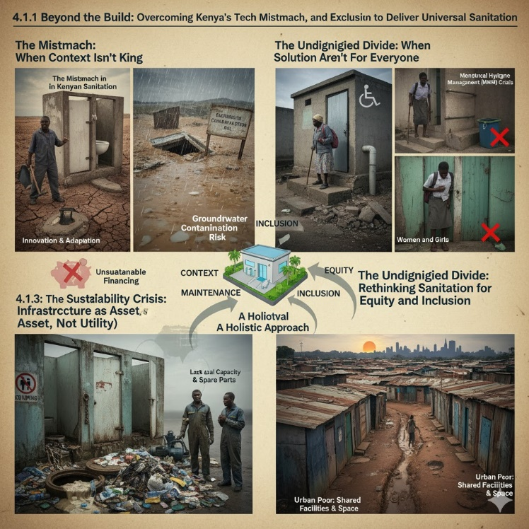

The problem stems from a **vicious cycle of neglect** and a fundamental **capacity and financing gap**:

1. **System Overload and Misuse:** Despite low connection rates, many systems suffer from severe blockages due to the improper disposal of solid waste (like diapers) into sewer lines or on-site sanitation systems. This misuse and general structural neglect lead to the discharge of untreated or partially treated fecal waste, posing significant public health risks. The infrastructure is incorrectly viewed as a one-off construction rather than a continuous service.
2. **Lack of Local Capacity:** Effective infrastructure maintenance is frequently hindered by a lack of local capacity. This deficiency is primarily defined by the consistent absence of technical skills and a reliable supply chain for spare parts at the community and local government levels.
3. **Unsustainable Financing:** Donor-funded facilities often fail because a lack of a sustainable financial model for upkeep forces local authorities to skip preventative maintenance, leading to major, costly repairs that they are unprepared to finance, ultimately wasting the initial investment.

Achieving sustainable sanitation 🚽 requires a fundamental shift in perspective: from viewing sanitation infrastructure as a one-off asset to recognizing it as a continuously managed utility

**4.1.4: The Undignified Divide: Rethinking Sanitation for Equity and Inclusion, nhen Solutions Aren't for Everyone**

Sanitation is a matter of dignity and equity, yet many projects fall short on **inclusivity**, leaving vulnerable groups without safe, accessible, and dignified facilities.

* **Persons with Disabilities (PWDs) and the Elderly:** Inclusive and equitable design is crucial for all community vulnerable members, particularly Persons with Disabilities (PWDs) and the Elderly, by ensuring that even simple modifications and features can transform traditionally inaccessible spaces into safe and usable environments.
* **Women and Girls:** While sanitation access is a general issue, women and girls have specific needs, particularly concerning **Menstrual Hygiene Management (MHM)**. The lack of clean, lockable, private facilities and appropriate disposal bins for menstrual waste in public spaces and schools not only compromises dignity but also contributes to blockages and environmental contamination.
* **The Urban Poor:** In dense informal settlements, land tenure insecurity, high population density, and limited space make the construction of individual pit latrines or connection to sewers challenging. Solutions must be adapted to these realities, focusing on safely managed shared facilities and decentralized faecal sludge management services that can operate effectively in tight, un-sewered environments.

Achieving universal and sustainable sanitation in Kenya requires moving beyond a focus on simple infrastructure targets. It demands a holistic approach that prioritizes **geological and environmental suitability**, establishes **robust O&M frameworks** with dedicated local resources, and places **equity and inclusivity** at the centre of design and implementation.

The journey toward sustainable sanitation in Kenya is impeded by a vicious cycle where the neglect of consistent operations and maintenance (O&M), particularly in fecal sludge management and funding, coupled with the lack of inclusive and accessible design, results in the rapid failure of facilities, causing severe public health crises and an estimated KES 27 billion annual economic burden.

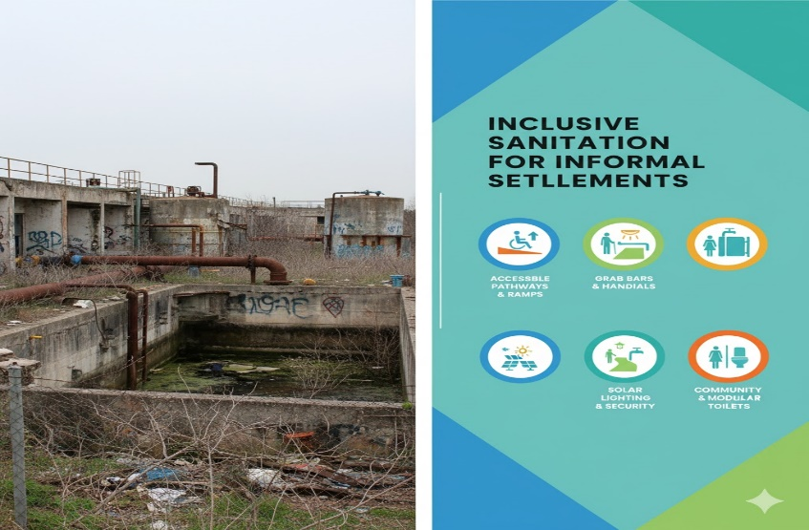 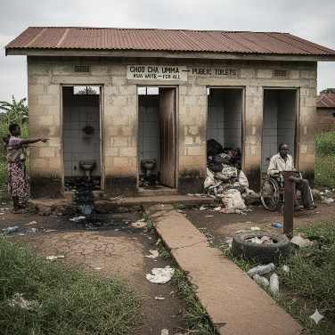

*Failure of neglected operations and maintenance and the simple, yet often overlooked, requirements for making facilities inclusive and accessible*

**Chapter 5. Chronic Underfunding and Low Prioritization of Sanitation 💰**

The sanitation sector in Kenya is paralyzed by a severe **funding crisis** rooted in its chronic **under prioritization** by national and county governments. By viewing sanitation merely as a 'social good' instead of a critical **economic enabler**, budgets are chronically under-allocated, leading to fragmented, donor-dependent solutions and preventing essential infrastructure development. This financial neglect carries a high price, driving costly public health epidemics and environmental damage while **forfeiting significant economic dividends** from improved productivity. Kenya must fundamentally shift perspective, recognizing that **ring-fenced budgets** and strategic private sector engagement are not just public health concerns, but a core **economic imperative** for national prosperity.

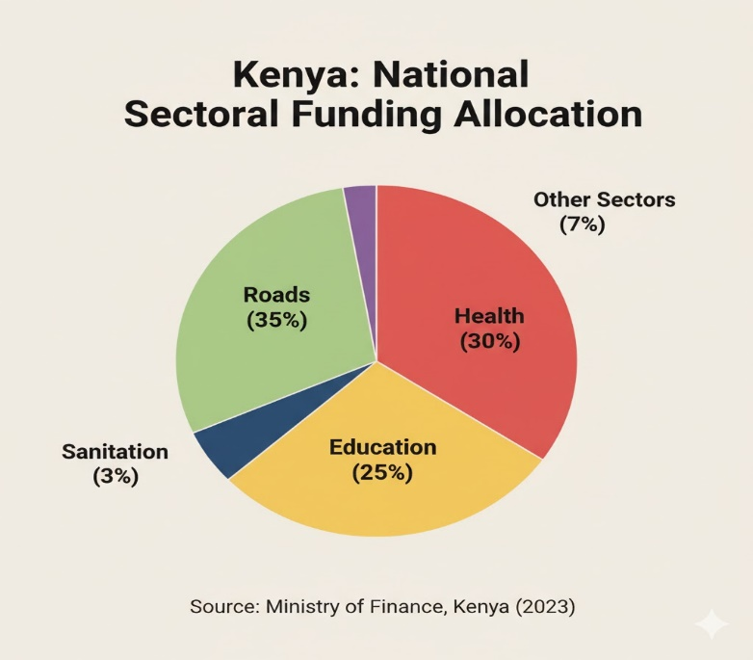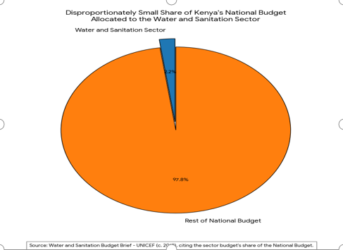

**S**anitation funding compared to larger slices for other sectors (e.g., roads, health, or education).

**5.1: Sanitation Crisis: Why Chronic Underfunding Stifles Progress 🚽🇰🇪**

The sanitation sector in **Kenya** faces a persistent and critical challenge: *Chronic underfunding.* Despite its foundational role in public health, economic development, and environmental sustainability, the sector consistently receives significantly less financial attention than other priority areas. This budgetary neglect is not merely an operational hurdle; it is the single largest factor slowing down the pace of sustained development and threatening the health and well-being of millions of Kenyans.

**5.1.1: The Root Cause: Inconsistent Prioritization**

The primary driver of the sanitation **funding shortfall** is its **inconsistent prioritization** in national investment plans and budgets. Sanitation often lacks the necessary **political will** and sustained budgetary allocations, as it is overshadowed by more visible sectors (like infrastructure and energy), making it vulnerable to cuts and leading to fragmented long-term planning.

The **consequences of this underinvestment are severe and far-reaching**: stagnated access perpetuates poor sanitation, directly fueling **public health crises** (such as cholera and typhoid) whose treatment costs often exceed the expense of prevention. Moreover, the lack of adequate infrastructure causes severe **environmental degradation** through unchecked dumping of raw sewage and ultimately stifles **economic growth**, losing out on significant job creation and high potential returns (estimated at up to $5 for every $1 spent).

To secure universal access to sanitation and hygiene by 2030, in line with **Sustainable Development Goal (SDG) 6.2**, Kenya urgently needs to adopt **sustainable and predictable financing mechanisms**, moving past ad-hoc funding. This strategy requires a three-pronged approach: **Elevate Prioritization** by embedding sanitation as a top-tier national investment with dedicated budget lines in all development plans; leverage **Innovative Financing** models such as **Public-Private Partnerships (PPPs)**, **Blended Finance** to de-risk projects, and **Tariff Reform** to ensure financial self-sufficiency through efficient user fee reinvestment; and **Strengthen Accountability** through enhanced transparency in budget expenditure and performance tracking against clear sanitation metrics. Addressing this funding gap is critical, as it is a developmental imperative that will unlock substantial public health, dignity, and economic benefits for a cleaner future.

In summary, Kenya's ambition for **universal, safely managed sanitation** is being undermined by a severe, yet often ignored, **underfunding crisis** within national and county budgets. This chronic fiscal neglect, which prioritizes new urban infrastructure over crucial operation and maintenance, exacts a heavy toll, costing the nation an estimated **0.9% of its GDP** annually through spiraling healthcare expenses, lost productivity, and deepening social inequalities that disproportionately affect women and the poor. The roots of this funding gap lie in low political priority, fragmented institutional responsibility, and a lack of specific budget codes. Addressing this demands a fundamental shift: **elevating sanitation to an economic imperative** and implementing **dedicated budget lines** to guarantee transparent, sustainable, and long-term investment.

**Chapter 6. Fragmented Governance and Poor Coordination**

The institutional environment in sanitation is severely fragmented, with many government departments and non-state actors operating simultaneously. This fragmentation results in overlapping mandates, confusion over responsibilities, and a critical lack of clear, effective coordination mechanisms across the sector.

The multi-layered structure of Kenya's sanitation presents a significant systemic challenge to achieving universal access and investment goals. While County Governments have the mandate for service delivery through Water Service Providers (WSPs), National Government bodies like the Ministry of Water, Sanitation and Irrigation (MoWSI), Ministry of Health, Ministry of Environment, and NEMA retain crucial policy, regulatory, and asset-holding roles. This dual mandate, further complicated by the unharmonized presence of numerous NGOs, creates acute confusion over essential functions—particularly asset ownership, tariff setting, and regulatory oversight—critically fragmenting the institutional environment and hindering the cohesive coordination mechanisms necessary to scale up sanitation service delivery and accelerate progress toward SDG 6.2.

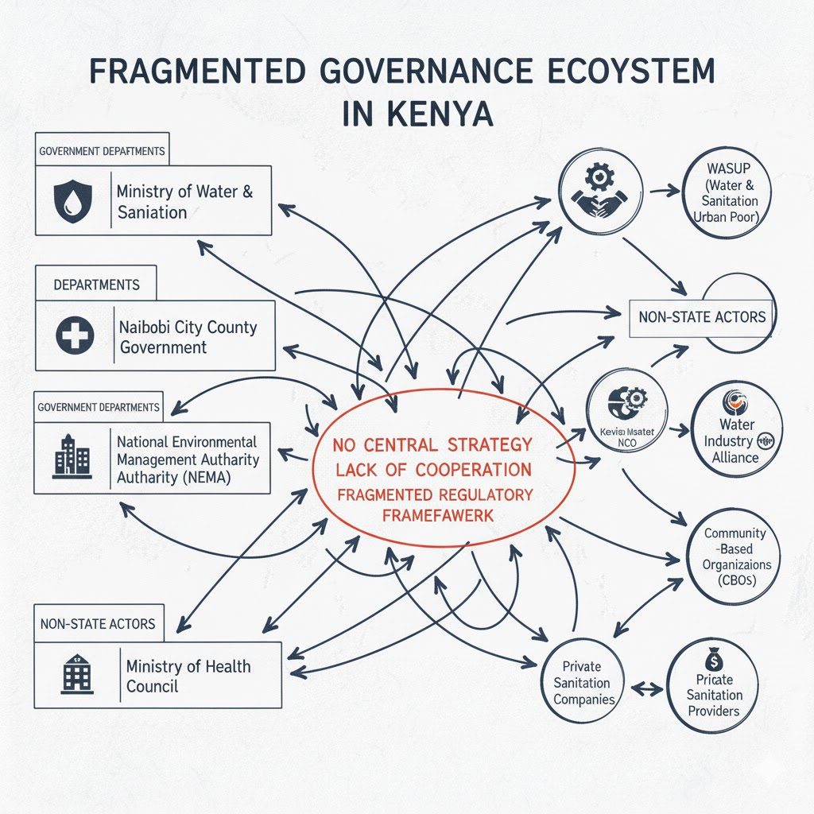

Disconnected government departments and non-state logos with arrows pointing in different, uncoordinated directions.

**6.1: Navigating the Labyrinth: Addressing Fragmented Sanitation Governance in Kenya 🇰🇪**

Kenya's pursuit of **universal and sustainable sanitation** is critically undermined by a deeply **fragmented governance ecosystem**. Despite the engagement of numerous government ministries, county administrations, and non-state organizations, their efforts often resemble a tangled web of disconnected initiatives and overlapping mandates. Complexities of this institutional fragmentation underscores the urgent necessity for a cohesive, collaborative strategy.

**The Current Landscape: A Kaleidoscope of Actors**

The sanitation space in Kenya is crowded. Key players include:

* National Government Ministries: Multiple ministries, including those responsible for Water, Health, and Environment, hold direct or indirect roles in policy and infrastructure.
* County Governments: Devolution has tasked all 47 counties with planning, financing, and delivering sanitation services, leading to diverse and sometimes inconsistent approaches.
* Regulatory and Service Bodies: Institutions like the National Environmental Management Authority (NEMA), Water Services Regulatory Board (WASREB) and various Water and Sanitation Service Providers (WSPs) enforce standards and manage utility services.
* Non-State Actors (NSAs): This broad category ranges from International NGOs providing funding and technical assistance to local CBOs, private sector companies involved in the sanitation value chain, and academic institutions driving research and innovation.

**6.2: The Pitfalls of Disconnection**

**The Five-Fold Cost of Disconnection**

The absence of a robust, central coordinating mechanism for sanitation has created a cascade of negative effects that undermine efficiency and equity:

1. **Duplication and Wasted Resources:** The lack of a unified, coordinated platform for Sanitation efforts results in detrimental duplication of services—wasting limited financial and human capital on geographically overlapping projects—which is a direct impediment to expanding coverage in unserved population.
2. **Gaps in Service Delivery:** Fragmented sanitation interventions create a "Swiss cheese" effect, focusing on isolated components and leaving critical gaps in the value chain (containment → emptying → treatment). A holistic, systems-based approach is essential to connect every link, ensuring that investments in services like household toilets are not undermined by the lack of coordinated infrastructure like safe FSM.
3. **Inconsistent Policies and Standards:** The absence of a unified strategic vision fosters conflicting sanitation policies and inconsistent enforcement across jurisdictions, creating a chaotic regulatory labyrinth that severely stifles private sector innovation, discourages investment, and prevents the scaling of proven best practices.
4. **Lack of Accountability:** The diffusion of responsibility and unclear mandates across sanitation actors create a severe accountability gap, obstructing institutional obligations and allowing substandard work to persist because responsibility for system failure cannot be decisively pinpointed.
5. **Difficulty in Attracting Investment:** The absence of a clear, coherent national sanitation strategy and the lack of aggregated data deter public and private investment by creating a high-risk, uncoordinated institutional environment.

Kenya's journey toward universal sanitation is significantly hindered, not by a lack of potential, but by **institutional fragmentation** that creates bottlenecks through siloed strategies and duplicated efforts across the sector. To urgently shift this narrative, progress demands a move to **unified governance**, necessitating the establishment of an empowered **apex body**. This central mechanism must be tasked with crafting a single, enforceable **National Sanitation Strategy**, harmonizing standards across all 47 counties, and implementing a centralized data platform to ensure transparency and accountability. Adopting this concerted, **whole-of-sector approach** is the non-negotiable key to overcoming Kenya's deep-seated coordination challenge, thereby unlocking its full potential and commencing an era of **collective impact** essential for delivering dignified sanitation service to every citizen

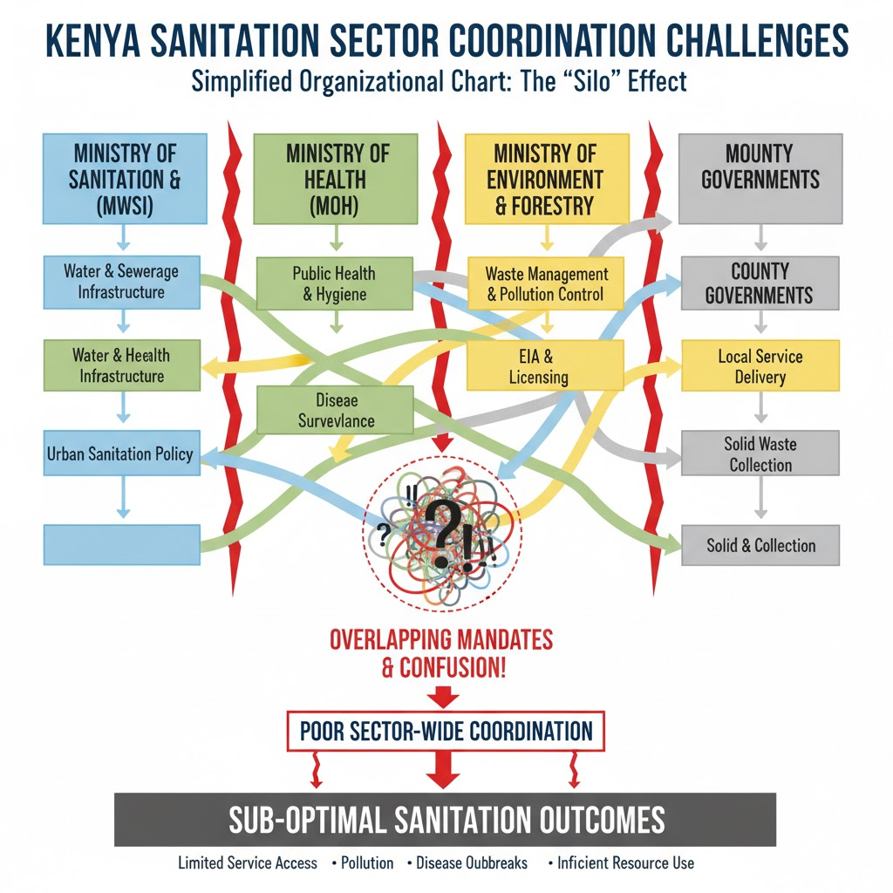

*The 'silo' effect: Multiple agencies' mandates overlap, leading to confusion and poor sector-wide coordination.*

**6.3: Institutional Cohesion and Regulatory Reform: The Dual Imperative for Kenya's Sanitation Goals:** The journey toward comprehensive and equitable sanitation in Kenya is significantly hampered by the "silo effect," a pervasive institutional challenge where key government agencies operate in isolation, focusing narrowly on their specific mandates without adequate coordination. This fragmentation is acutely felt across the sector, with responsibilities for water infrastructure, public health, waste management, and local service delivery scattered across multiple ministries and county governments. The result is a cycle of confusion, duplication of effort, and a lack of holistic planning; for instance, a new water project may be implemented without adequate provision for accompanying sanitation and waste disposal, thus undermining its overall public health impact. Addressing this requires establishing robust inter-agency coordination mechanisms and a shared strategic framework to break down institutional barriers and move closer to achieving Kenya's sanitation goals.

To achieve SDG 6.2, Kenya must urgently codify and harmonize its sanitation regulations. This requires developing National FSM Guidelines and Model County By-Laws. Concurrently, there is a need for stronger regulatory capacity to establish the legal foundation essential for sustained, safe, and equitable sanitation services across the nation.

**Chapter 7. Sanitation Data Deficiencies and Lack of Unified Monitoring 📊**

The path to effective sanitation in Kenya is significantly impeded by a critical **data deficit**. The current absence of a **unified monitoring system** and a single, reliable source of comprehensive data severely obstructs both **resource allocation and evidence-based planning**. This gap is most acute in **informal settlements**, leaving decision-makers blind to specific needs and making it profoundly challenging to design and implement **targeted, effective interventions** that can truly accelerate progress towards universal, safe sanitation.

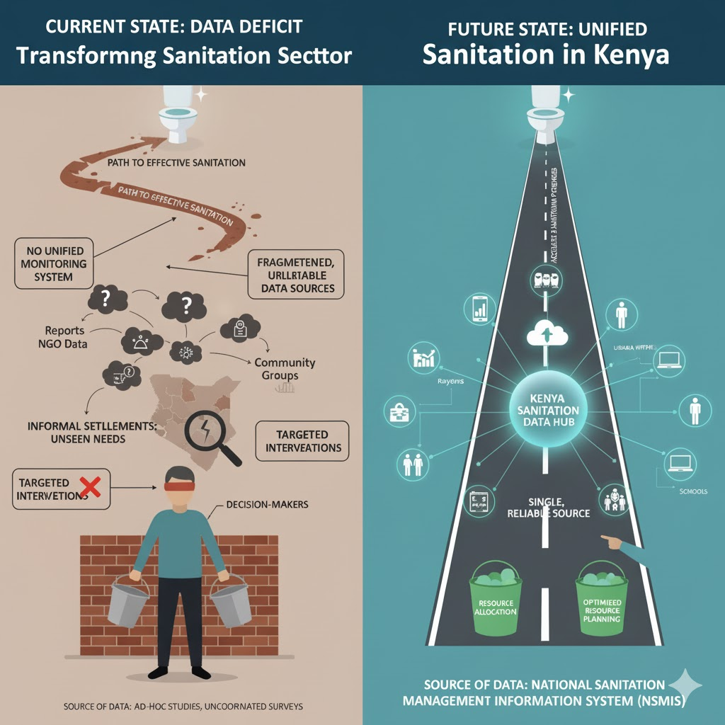

Bridging the Data Gap: Transforming Sanitation in Kenya

**7.1: Kenya's Sanitation Crisis: The Cost of Flying Blind in the sanitation sector progress 📉**

Effective resource allocation and planning for sanitation in Kenya are severely obstructed by a critical gap: the **absence of a unified monitoring system** and a single, reliable source of comprehensive data. This data deficit is particularly acute in Kenya's rapidly growing urban **areas and informal settlements**, making targeted interventions and evidence-based decision-making challenging, and costing the country billions.

**7.2: The Vicious Cycle of Missing Data**

Kenya's sanitation challenge is immense; millions lack access to safe toilets, yet without a cohesive national system to track performance, investment, and coverage across all devolved levels (county, sub-county, and settlement-specific):

* **Resource Allocation is Guesswork:** Decision-makers struggle to precisely pinpoint areas of greatest need, leading to the misallocation of scarce public and donor funds. Investment often favours visible main sewers over crucial **Non-Sewered Sanitation (NSS) solutions**—the backbone of service to the highest population.
* **Accountability is Fragmented:** With various government departments, utilities, NGOs, and private operators involved, the lack of a centralized platform means there's no clear, real-time mechanism to hold service providers accountable or to track the true impact of investments.

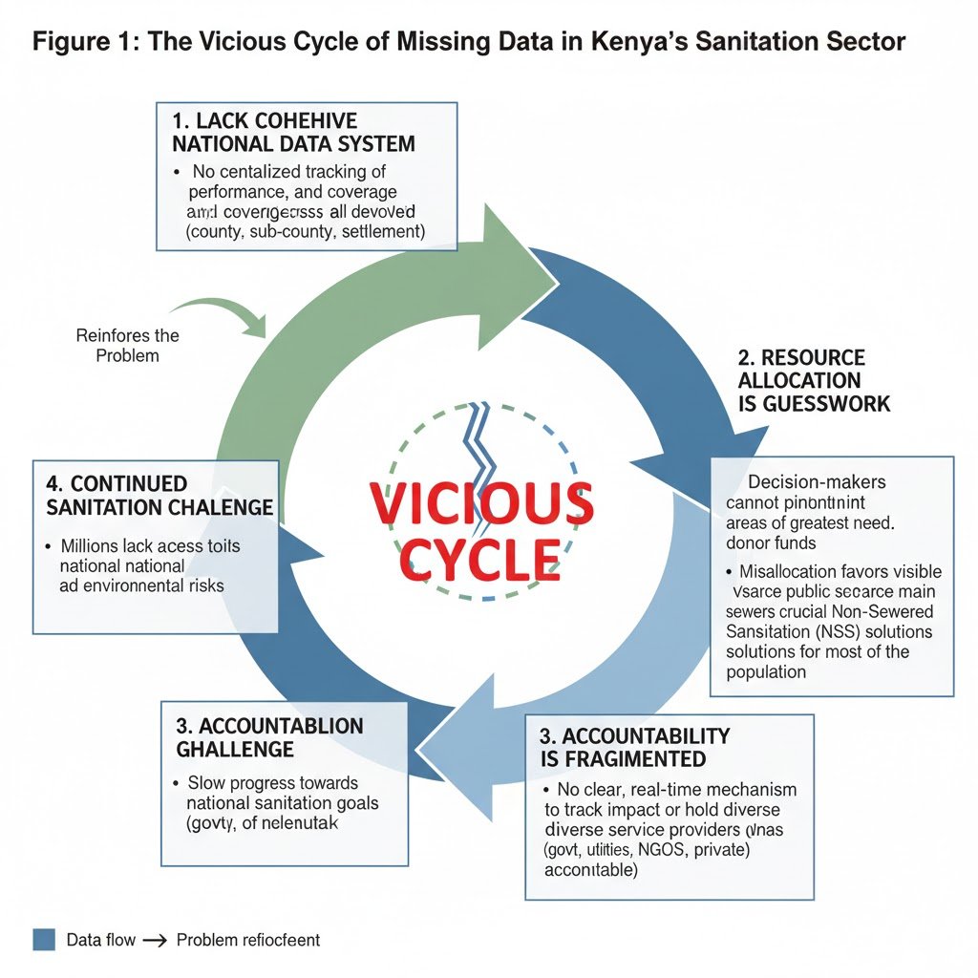

Impact of a fragmented system

**7.3:The Data Gap Crippling Kenya's Sanitation Efforts**

## The lack of **reliable data** on Kenya's urban informal settlements is the fundamental constraint perpetuating the sanitation crisis, a phenomenon of '**planning in the dark**' that results in poorly targeted interventions and the wasteful deployment of scarce resources. This systemic failure tragically perpetuates severe public health risks for millions. Moving forward, the priority must shift from reacting to infrastructure gaps to proactively **constructing knowledge**. Kenya must strategically invest in **digital mapping**, local-level data collection, and collaborative frameworks to permanently bridge the information divide. A robust, dynamic data ecosystem is the foundational prerequisite for effective, equitable policymaking, ensuring future sanitation efforts are precise, accountable, and finally deliver the sustained dignity and health stability that all Kenyans deserve.

**Chapter 8: Developing a Sanitation Actors Directory for Kenya**

The development of a comprehensive directory of sanitation actors in Kenya is a crucial step towards **enhanced sector coordination, efficiency, and accountability**. Given the decentralized nature of water and sanitation services following Kenya's devolution, and the diverse range of stakeholders, a central, accessible directory is essential for effective collaboration and resource mobilization to achieve national sanitation goals, such as those outlined in the National Sanitation Management Policy.

**Key Actors in Kenya's Sanitation Sector**

The sector is characterized by a complex array of public, private, and non-state entities, each with distinct roles:

* **National Government Institutions:** The **Ministry of Water, Sanitation and Irrigation (MoWSI)**, through its Sanitation Directorate, holds the primary policy, coordination, and investment planning mandate. The **Ministry of Health** remains crucial, especially for environmental health and hygiene promotion (e.g., Community-Led Total Sanitation - CLTS).
* **Regulatory Bodies:** The **Water Services Regulatory Board (WASREB)** regulates urban and rural water and sewerage services, setting standards and issuing licenses. The **National Environment Management Authority (NEMA)** handles environmental regulation, including wastewater discharge standards.
* **County Governments:** Under the Constitution, **County Governments** are primarily responsible for the provision of water and sanitation services, including infrastructure development, planning, and service delivery oversight within their jurisdiction.
* **Service Providers:** These include the **Water Service Providers (WSPs)**, often utility companies delegated by Water Services Boards (now mostly integrated into County structures), and the **private sector**, such as pit emptiers (e.g., the Septage Emptiers Association of Kenya - SEAK), social enterprises, and construction firms involved in the entire sanitation value chain (containment, emptying, transport, treatment, and disposal/reuse).
* **Non-State Actors (NSAs):** This vital group includes **NGOs/CSOs** (e.g., WASH Alliance Kenya) and **Development Partners** (e.g., World Bank, UNICEF, GIZ), who provide financial, technical, and implementation support. **Academic and research institutions** also contribute through data, innovation, and capacity building.

**Directory Development Methodology**

Creating the directory requires a systematic approach to ensure it is robust, current, and useful.

1. **Scope Definition and Classification:**
   * Clearly define the **sanitation value chain** stages (toilet provision, containment, emptying/transport, treatment, disposal/reuse) and the sectors (urban, rural, institutional).
   * Establish a **classification system** based on the key actor groups (Government, Regulator, Utility/WSP, Private Sector, NGO/CSO, Development Partner).
2. **Data Collection and Validation:**
   * Utilize **desk review** of policy documents and existing databases (e.g., WASREB's reporting).
   * Employ **surveys and Key Informant Interviews (KIIs)** with known sector leaders for initial data and to identify other actors.
   * **Validate** collected information (contact details, operational area, mandate) through official verification channels or cross-referencing.
3. **Structure and Content:**
   * The directory should be organized for easy retrieval, potentially using both sectoral and geographical (County-based) indexing.
   * **Essential Data Points:**
     + **Name and Acronym** of the organization.
     + **Type of Actor** (e.g., County Department of Health, WSP, NGO).
     + **Operational Area(s)** (e.g., Nairobi County, specific sub-counties).
     + **Primary Role/Mandate** in the sanitation value chain (e.g., Fecal Sludge Management, Hygiene Promotion, Regulation).
     + **Contact Information** (key personnel, phone, email, website).
4. **Platform and Maintenance:**
   * The directory should be hosted on an **accessible platform** (e.g., an online, searchable database) under the oversight of a lead national institution (likely MoWSI or a multi-stakeholder platform).
   * A clear protocol for **regular updates and validation** (e.g., quarterly or biannually) is necessary to ensure the information remains accurate and relevant.

**Expected Impact and Utility**

A well-maintained sanitation actors directory offers numerous benefits:

* **Improved Coordination:** It allows for quick identification of partners in a specific geographic area or value chain segment, reducing duplication of efforts and fostering integrated planning, particularly at the County level.
* **Enhanced Transparency:** By making actors and their mandates public, it improves accountability to communities and promotes sector-wide transparency.
* **Informed Decision-Making:** Regulators, policymakers, and investors can use the directory to map capacities, identify gaps, and target support effectively.
* **Market Development:** It helps link service seekers (e.g., households needing pit emptying) with verified service providers, stimulating the private sanitation market.